**Club Members Sail Croatia**

This past September, members Phil Dunn and Banu Zolnik chartered a cabin on *Tiger Lil’,* a Fontaine-Pajot Elba 45-foot catamaran, from former long-time Club member and charter boat owner and Capt. Bob Riley (Cabin Charter Sailing LLC). The following is the account of their 9-day sail with Bob as their captain along the Croatian coast.

**The Croatian Coast**

When imagining beautiful, fascinating, Mediterranean sailing, the Croatian Coast should be at the top of your list - azure waters, towns from paintings, and plenty of history with the Roman, Austro-Hungarian and Ottoman Empires. We hope to give everyone a quick flavor of the trip and some practical details if you wish to pursue a similar trip.

**Weather & Geography**

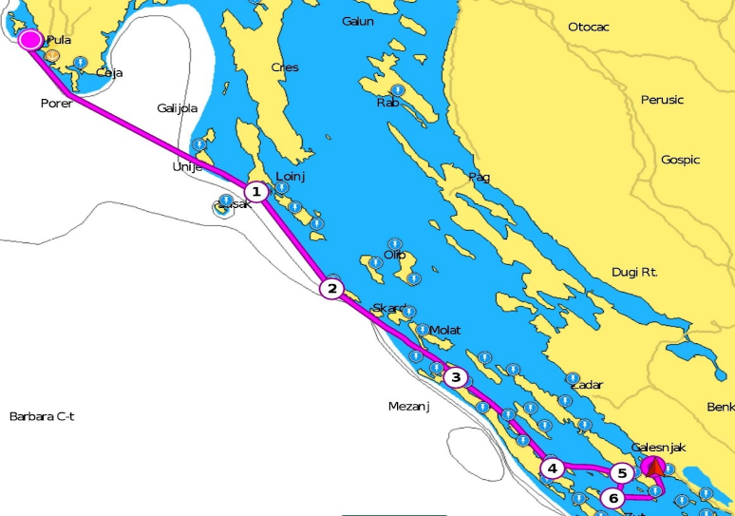Our trip took us from Pula to Biograd, stopping at ports and mooring spots along the way.  The ports were towns of various sizes and the mooring spots all have a local restaurant where you can go to get dinner or drinks.

*Map of trip along Croatian coast*

*Embark: Pula (port), 1. Mali Losinj (port), 2. Premuda (mooring), 3. Bosava (port), 4. Sali (port), 5.Soline Pasman (mooring), 6. Hijaca-Zut (mooring), Disembark: Biograd na Mer (port)*

Sailing ranged from 25+knot winds and heavy seas (day 1 on the Adriatic) to becalmed glassy seas. The weather was generally in the 70-80s and sunny (sunce!).  We were fortunate enough to avoid an extended unseasonably cold (50s) and rainy period earlier in September that caused us to pack warm clothes.  So, check the weather reports. The water in September was warm and it was easy to swim every day.

There are generally two weather patterns, [Jugo & Bura](https://croatia.hr/en-gb/nautical/jugo-the-moody-king).  The Jugo is from the south, and Bura from the north.  We encountered the Jugo (pictured) at the end of our trip and so we spent an extra day in Biograd.

**Our Stops**

***Pula*** is a beautiful, relatively large town port and local tourist spot with a great deal to see and many excellent restaurants.  It was home to a Roman amphitheater, Roman walls and gate, a fortress overlooking the port from the Austro-Hungarian period. It’s easy to spend a few days here.

***Mali Losinj*** is a very pretty medium town port with beautiful blue waters and many shops and restaurants

***Premuda*** is a mooring spot with clear azure waters with schools of fish.  It was one of our favorites.

***Bosava*** (pictured) is a picturesque small port with beautiful rocky beaches around the peninsula.  Careful, the rocks can be slippery.

***Sali*** is a very pretty medium town port with many shops and restaurants.  Follow the path around the peninsula to find a hidden beach club in the inlet.

***Soline Pasman*** is a grassy mooring site with a little inn.

***Hijaca-Zut (mooring)*** is another of our favorite moorings.  We could see down six meters to the mooring anchor.  Schools of fish and a large local octopus lived there.

***Biograd na Mora*** is home of *Tiger Lil*; a larger port with a lot to explore and options to take a bus or rent a car to other nearby sites (Sibenek or Zadar) or a longer trip to the Plitvice mountain lakes & waterfalls.

**Croatian Docking System**

Docking in Croatia (and I assume many parts of the Mediterranean)  uses a different system of lines.  Boats dock stern-in attaching two stern lines to the dock, usually a concrete quay. The lines are looped and will be cleated on the stern after the bow lines are secured.

For the bow, two fixed, lazy lines extend from the quay out about 60ft to a mooring anchor.  After stern lines are attached, these fixed lazy mooring lines are hooked close to the quay, and pulled up from the bottom as the hand walks out to the bow cleats.  The hand pulls the line firm against the mooring anchor, balancing with the stern lines to adjust the distance from the quay.  Spring lines are generally not used. However, Bob did use a springline configuration across the stern.  For more fine points, [see video example here](https://www.youtube.com/watch?v=jULddr4KA50).

**Travel**

We flew into Istanbul and took a second flight to Zagreb and then a local Croatian Air flight to Pula and then back from Zadar.  Others on the sail flew into Venice or via Germany.  We spent some extra days in Zagreb to avoid any connection issues.

Be careful of the cabbies at the airports.  They’ll charge you whatever pops into their heads.  Check prices against Uber.